Master

1. **CompanyMaster**

Create Company Master.

**Table :** tblCompany

**Functionality :**

1. Add Company
2. Update Company
3. Delete Company
4. View Detail

**Form Design :**

1. Company Master

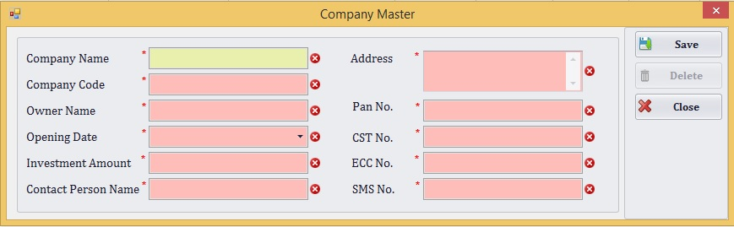

**Employee Master**

Create Employee Master.

**Table:** tblEmployee

**Functionality:**

1. Add Employee
2. Update Employee
3. Delete Employee
4. View Detail

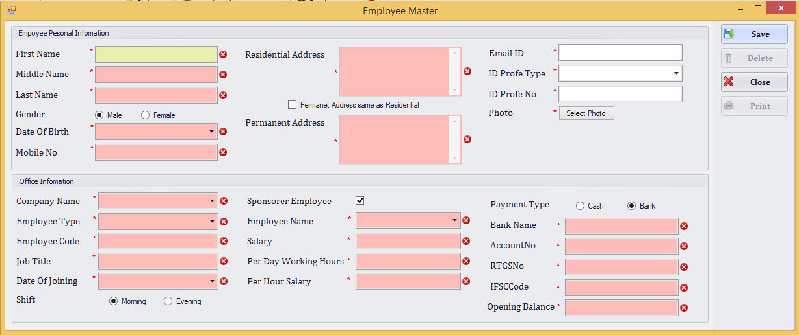

**Employee Type Master**

Create Employee Type Master.

**Table:** tblEmployeeTypeMST

**Functionality:**

1. Add Employee Type
2. Update Employee Type
3. Delete Employee Type
4. View Detail

**Design:**

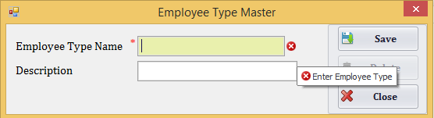

1. **Party Master**

Create Party Master.

**Table :** tblPartysMST

**Functionality :**

1. Add Party
2. Update Party
3. Delete Party
4. View Party

**Form Design:** Party Master

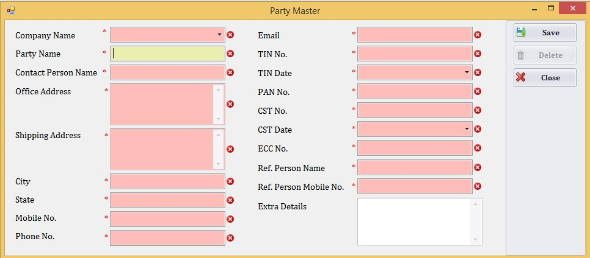

**Penalty Master**

Create Penalty Master.

**Table :** tblPenaltyMST

**Functionality :**

1. Add Penalty
2. Update Penalty
3. Delete Penalty
4. View Penalty

**Form Design**: Penalty Master

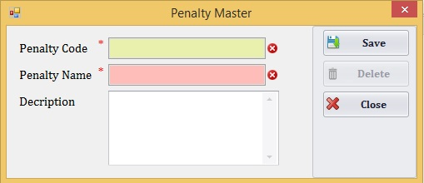

**Yarn Package Type**

Create Yarn Package Type Master

**Table :** tblYarnPackageType

**Functionality :**

1. Add Yarn Package Type
2. Update Yarn Package Type
3. Delete Yarn Package Type
4. View Yarn Package Type

**Form Design**: Yarn Package Type

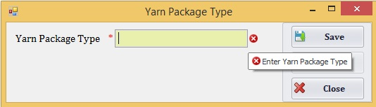

**Yarn Quality Master**

Create Yarn Quality Master.

**Table :** tblYarnQualityMST

**Functionality :**

1. Add Yarn Quality Master
2. Update Yarn Quality Master
3. Delete Yarn Quality Master
4. View Yarn Quality Master

**Form Design** : Yarn Quality MST

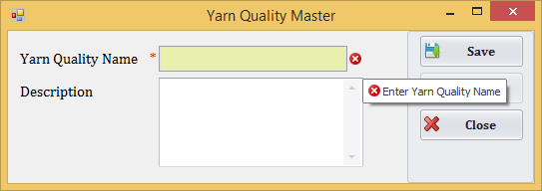

**Yarn Type Master**

Create Yarn Type Master.

**Table :** tblYarnTypeMST

**Functionality :**

1. Add Yarn Type Master
2. Update Yarn Type Master
3. Delete Yarn Type Master
4. View Yarn Type Master

**Form Design**: Yarn Type MST

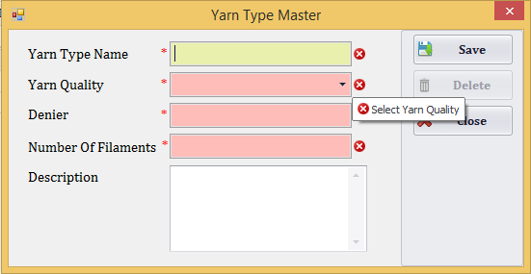

Create Machine Master.

**Table :** tblMachineMST,tblMachineTypeMST

**Functionality :**

1. Add Machine Master
2. Update Machine Master
3. Delete Machine Master
4. View Machine Master

**Form Design** Machine master

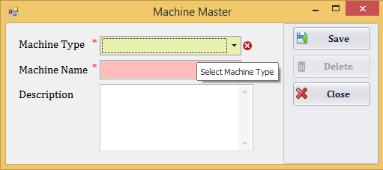

**Machine Type Master**

Create Machine Type.

**Table :** tblMachineTypeMST

**Functionality :**

1. Add Machine Type Master
2. Update Machine Type Master
3. Delete Machine Type Master
4. View Machine Type Master

**Form Design** Machine Type Master

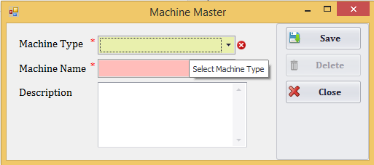

**Bank Master**

Create Bank.

**Table : tblBankMST**

**Functionality :**

1. Add Bank Master
2. Update Bank Master
3. Delete Bank Master
4. View Bank Master

**Form Design** Bank Master

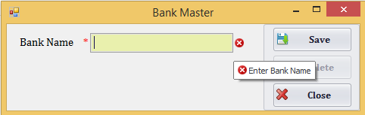

**Branch Master**

Create Branch Master.

**Table :** tblBranchMST,tblBankMST

**Functionality :**

1. Add Branch Master
2. Update Branch Master
3. Delete Branch Master
4. View Branch Master

**Form Design** Branch master

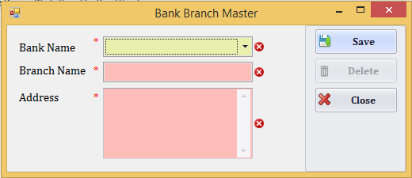

**Broker Master**

Create Broker Master.

**Table :** tblBrokerMST,tblPartyMST

**Functionality :**

1. Add Broker Master
2. Update Broker Master
3. Delete Broker Master
4. View Broker Master

**Form Design** Branch master

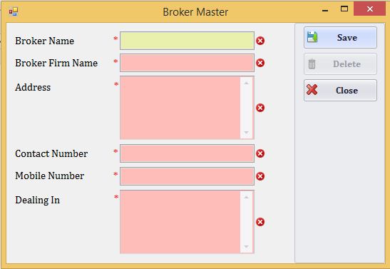

**Working Year**

Create Working Year.

**Table :** tblWorkingYear

**Functionality :**

1. Add Working Year
2. Update Working Year
3. Delete Working Year
4. View Working Year

**Form Design** Working Year

Year Name :

Cancel

Add

**Boiler Process**

Create Boiler Process.

**Table :** tblBoilerProcess, tblEmployee, tblMachineMST

**Functionality :**

1. Add Boiler Process
2. Update Boiler Process
3. Delete Boiler Process
4. View Boiler Process

**Form Design :** Boiler Process

Machine ID

Employee Name

Shift

StartDateTime

EndDateTime

Tempreture

Cancel

Add

**Boiler Process Details**

Create Boiler Process Details.

**Table :** tblBolierProcessDetails, tblYarnQualityMST, tblBoilerProcess, tblTFOProcess

**Functionality :**

1. Add Boiler Process Details
2. Update Boiler Process Details
3. Delete Boiler Process Details
4. View Boiler ProcessDetails

**Form Design** : Boiler Process Details

Boiler Process ID

TFO Role Process ID

Issue No Of TFO Roles

Issue Weights

Yarn Quality ID

Cancel Cancel

Add

**Mending Process**

Create Mending Process.

**Table** : tblMandingProcess**,** tblEmployee

**Functionality :**

1. Add Mending Process
2. Update Mending Process
3. Delete Mending Process
4. View Mending Process

**Form Design** : Mending Process

Taka No

Employee Name

Grade

Start Date Time

End Date Time

Total Meter

Total No Of Faults

Cancel Cancel

Add

**Mending Process Detail**

Create Mending Process.

**Table** : tblMandingProcess**,** tblEmployee, tblMendingDetailsProcess

**Functionality :**

1. Add Mending Process Details
2. Update Mending Process Details
3. Delete Mending Process Details
4. View Mending ProcessDetails

**Form Design** : Mending Process Details

Mending ID

Employee Name

Start Meter

End Meter

Cancel

Add

**Mending Penalty**

Mending Penalty Process Creation.

**Table** : tblMendingPenulty**,** tblEmployee, tblPenaltyMST

**Functionality :**

1. Add Mending Penalty
2. Update Mending Penalty
3. Delete Mending Penalty
4. View Mending Penalty

**Form Design** : Mending Process Details

Employee Name

Penalty ID

Cancel

Add

**Looms Process**

Create LoomsProcess.

**Table** : tblLoomProcess**,** tblBeemProcess, tblMachineMST

**Functionality :**

1. Add LoomsProcess
2. Update LoomsProcess
3. Delete LoomsProcess
4. View LoomsProcess

**Form Design** : LoomsProcess

Beem Process ID

Machine ID

Noof TFO Role

Creatoin Date Time **Looms Process Work**

Add

Cancel

Create LoomsProcess work.

**Table** : tblLoomProcess**,** tblLoomProcessWork, tblMachineMST

**Functionality :**

1. Add LoomsProcess work
2. Update LoomsProcess work
3. Delete LoomsProcess work
4. View LoomsProcess work

**Form Design** : LoomsProcess work

LoomProcessID

EmployeeID

WorkingDate

StartTime

EndTime

Shift

MTRStart

MTREnd

Add

Cancel

**Winding Work**

Create Winding Work.

**Table** : tblEmployee**,** tblWindingWork, tblMachineMST, tblYarnQualityMST, tblYarnTypeMST

**Functionality :**

1. Winding work
2. Update Winding work
3. Delete Winding work
4. View Winding work

**Form Design** : Winding work

MachineId

Employee Name

PuchaseItemId

Shift

StartDateTime

TotalIssueWeight

WastedWeight

ProductionWeight

NoOfCopes

EndDateTime

YarnQualityId

YarnTypeId

**TFO Role Processing**

Add

Cancel

Create TFO Role Processing.

**Table** : tblEmployee**,** tblWindingWork, tblMachineMST, tblYarnQualityMST, tblYarnTypeMST

**Functionality :**

1. Winding work
2. Update Winding work
3. Delete Winding work
4. View Winding work

**Form Design** : TFO Role Processing

Winding Process Id

Purchase Item ID

Machine Id

Employee Id

Shift

Start Date Time

Issue No Of Copes

Issue Weights

No of TFO Role

Production No Of TFO Roles

Production Weights

Quality Name

End Date Time

Yarn Quality Id

Yarn Type Id

Cancel

Add

**Beam Master**

Create Beam Master.

**Table :** tblBeamMST, tblCompany

**Functionality :**

1. Add Beam Master
2. Update Beam Master
3. Delete Beam Master
4. View Beam Master

**Form Design** : Beam Master

Company Name

Wrapper PartyName

Jobber PartyName

BeemDate

Yarn Quality

Gray Quality

TarNo

Meters

Taka

Weight

Production Meters

Production Taka

Pipe Weight

Loading Date

Min Stragy

Machin No

Remarks

Bhidan Status

Bhidan Date

Pasarai Name

Count

Issu Date

Taka Meter

Rate

Amount

Meter Consumption

RPM

Pick

Cancel

Add

**Beam Process**

Create Beam Process.

**Table :** tblBeemProcess, tblEmployee, tblMachineMST

**Functionality :**

1. Add Beam Process
2. Update Beam Process
3. Delete Beam Process
4. View Beam Process

**Form Design** : Beam Process

Machine ID

Employee Name

Shift

StartDateTime

EndDateTime

Add

Cancel

**Beam Process Details**

Create Beam Process Details.

**Table :** tblBeemProcess, tblTFOProcess , tblYarnQualityMST , tblYarnTypeMST, tblBemProcessDetails

**Functionality :**

1. Add Beam Process Details
2. Update Beam Process Details
3. Delete Beam Process Details
4. View Beam Process Details

**Form Design** : Beam Process Details

Beam Process ID

TFO Role Process ID

Issue No Of Copes

Issue Weights

Yarn Quality ID

Yarn Type ID

Add

Cancel

**Company Machine Master**

Create Company Machine Master.

**Table :** tblCompanyMachineMST,tblMachineMST,tblCompanyMST

**Functionality :**

1. Add Company Machine Master
2. Update Company Machine Master
3. Delete Company Machine Master
4. View Company Machine Master

**Form Design** Machine master

Machine Name:

Comapny Name:

Add

Cancel

**Product Quality Master**

Create Product Quality Master.

**Table :** tblProductQualityMST

**Functionality :**

1. Add Product Quality Master
2. Update Product Quality Master
3. Delete Product Quality Master
4. View Product Quality Master

**Form Design** : ProductQualityMaster

**Form Design :** Product Quality Master

WARP SIDE WEFT SIDE

Product Quality Name

WARP Denier After TPM

WARP Number Of Filaments

WARP Yarn Quality Name

WARP Yarn Type Name

WARP Direction Of Twist S

WARP Direction Of Twist Z

WARP Twist Per Meter S

WARP Twist Per Meter Z

Total Ends With Border (Approx)

Reed ON LOOM

Width ON FANI

Border

Heat Setting

Weight Of Fabric WARP

Weight Of Fabric WEFT

Total Weight

Cancel

Add

**Withdrawn Master**

Create Withdrown Master.

**Table :** tblWithdrownMST, tblEmployee

**Functionality :**

1. Add Penalty
2. Update Penalty
3. Delete Penalty
4. View Penalty

**Form Design** : Withdrawn Master

Employee Name

Remarks

Withdrown Amount

Withdrown Date

Return Date

Add

Cancel

**Withdrawn Return Master**

Create Withdrown Return Master.

**Table :** WithdrownReturnMST, tblEmployee, tblSalaryMST

**Functionality :**

1. Add Withdrown Return Master
2. Update Withdrown Return Master
3. Delete Withdrown Return Master
4. View Withdrown Return Master

**Form Design** : Withdrown Return Master

Date :

Cancel

Employee Name

Return Type

Salary ID

Amount

Remark

Add

**Salary Master**

Create Salary Master.

**Table :** tblSalaryMST, tblWithdrownMST, tblEmployee

**Functionality :**

1. Add Salary Master
2. Update Salary Master
3. Delete Salary Master
4. View Salary Master

**Form Design** : Penalty Master

Employee Name

Date

Start Date

End Date

Worked Hours

Total Penalty

Bonus

Withdrown Amount

Withdrown ID

Net Salary

Add

Cancel

**Attandance Master**

Create Attendance Master.

**Table :** tblAttendanceMST, tblEmployee

**Functionality :**

1. Add Attendance Master
2. Update Attendance Master
3. Delete Attendance Master
4. View Attendance Master

**Form Design** : Attandance Master

Employee Name

StartTime

EndTime

MeterWorked

Add

Cancel